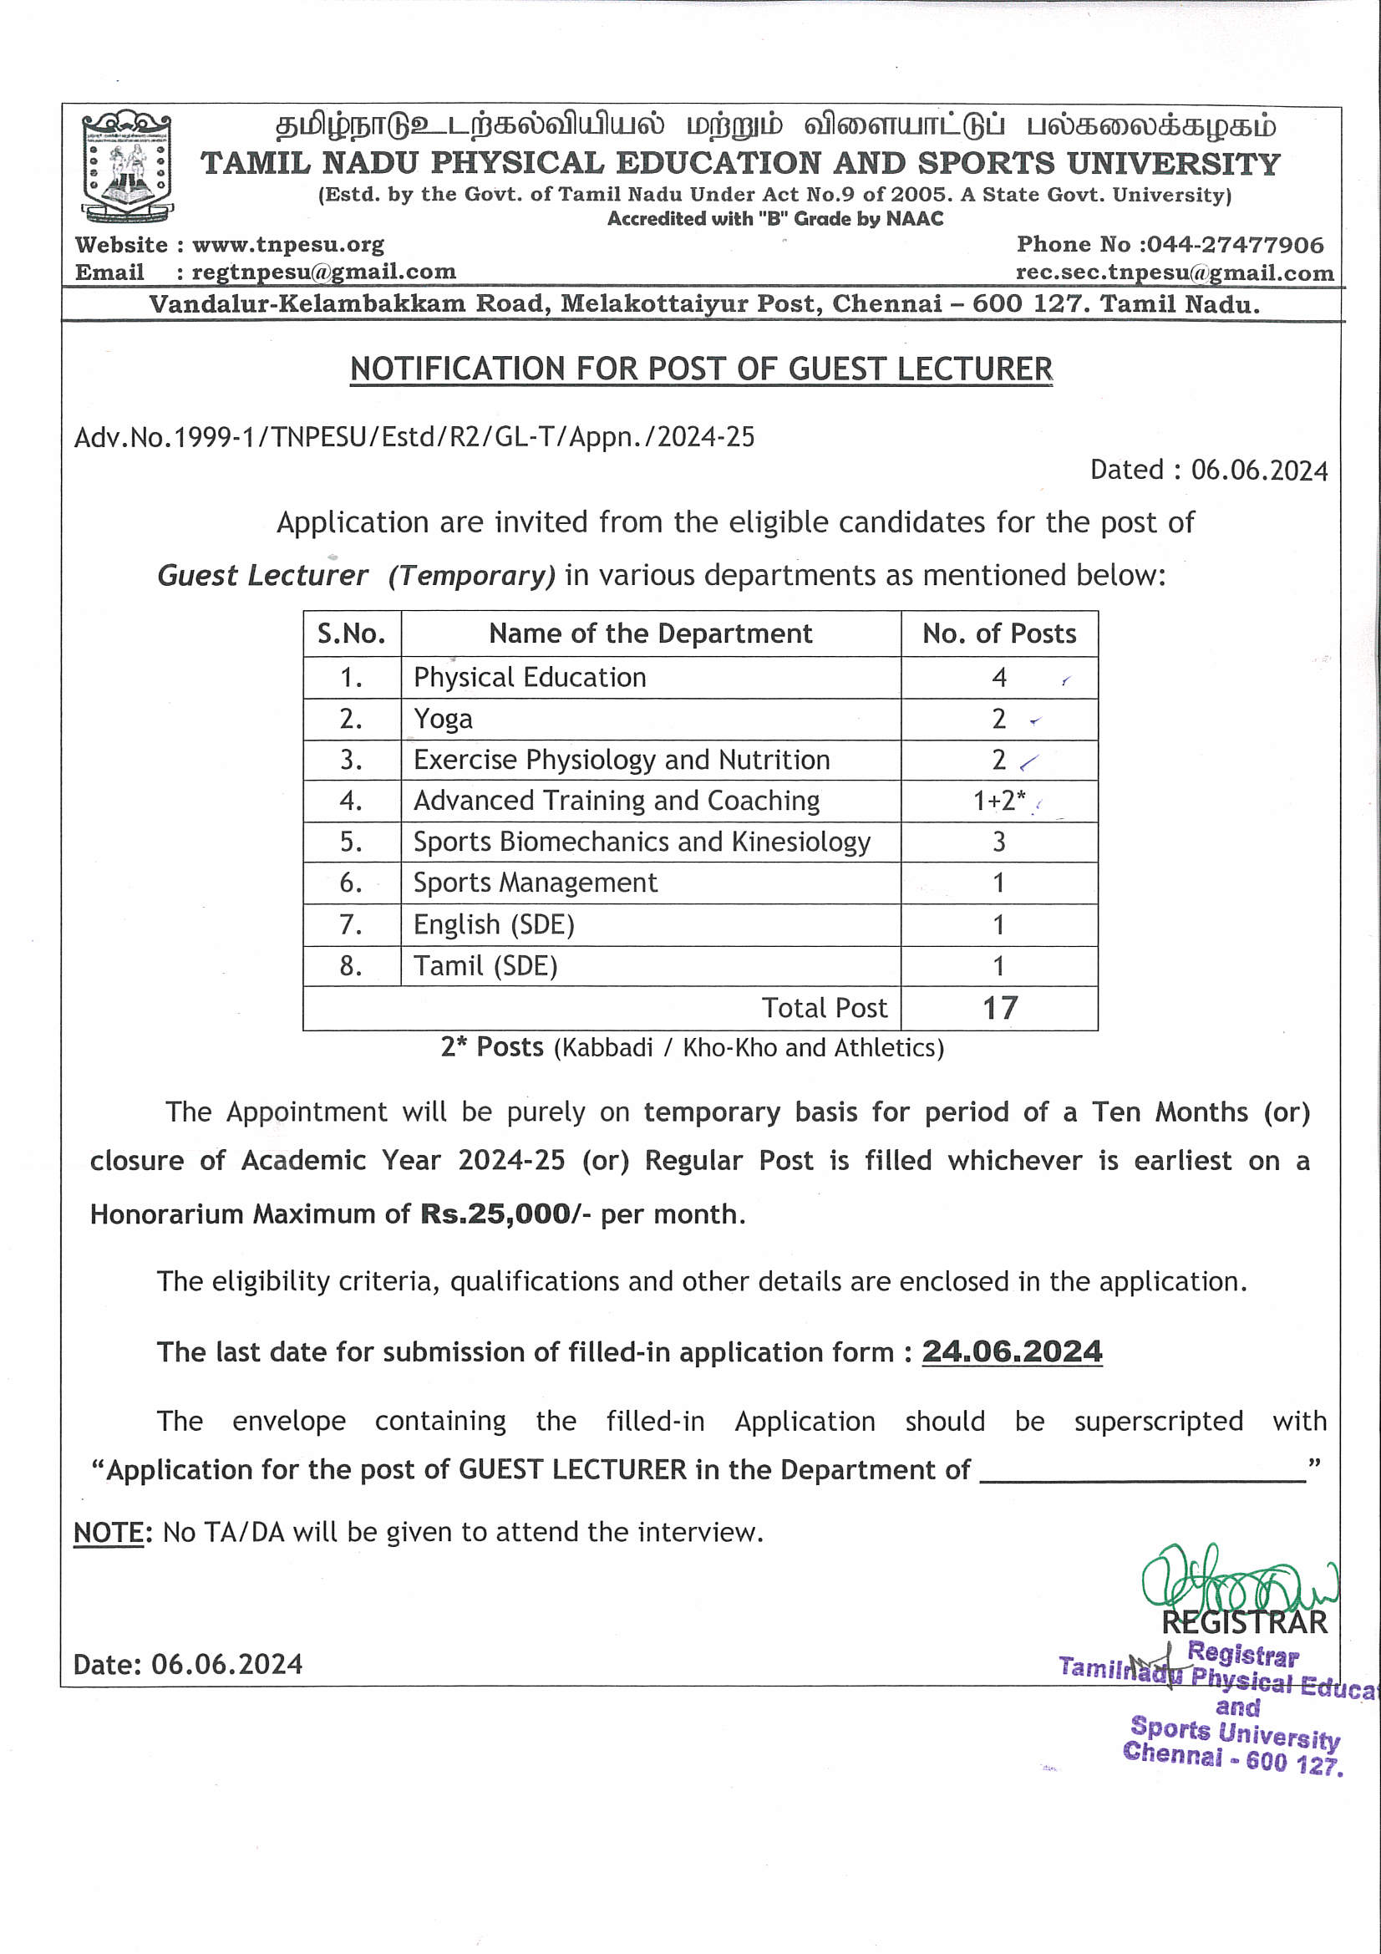

Instructions to the Candidates FOR THE post of Guest LECTURER
- The details of qualification are given in the Annexure
- The Appointment will be purely on temporary basis for a period of Ten months on a consolidated salary of Rs.25,000/- per month.
- Separate Application and Payment are required for each post applied.
- University reserves the right to fill or not to fill-up the post without assigning any reasons whatsoever. If no suitable female candidates are available, male candidates will be considered against these posts and vice versa.
- Any attempt, by the candidate, either directly or indirectly to influence the Selection Committee or other authorities of the University will disqualify the candidate for the post.
- The application form shall be filled- in, complete in all respects, giving correct information. Defective and incomplete application and those with wrong or false information will be summarily rejected.
- Evidence of Experience and Degree/Diploma Certificates should be brought in original at the time of interview. Self-attested Copies of Certificates, Mark-Sheets, Testimonials, etc., should be attached with the application and must be produced at the time of interview and at the time of joining, if selected. The Selected candidate shall produce, in original, the Matriculation or equivalent certificates as proof of the date of birth. No other evidence will be accepted.
- No interim queries regarding test / interview/ selection will be entertained.
- The applications received after the last date for the receipt of the application, will not be entertained for consideration and it will be rejected and the cost of applications so remitted in any form will not be refunded.
- The Cost of Application Form Rs. 250/- for SC/ST (should produce copy of community certificate) and for Differently Abled Person (appropriate certificate should be attached) and Rs. 500/- for Other Community. The Demand Draft shall be drawn in favour of “The Registrar, Tamil Nadu Physical Education and Sports University”, payable at Chennai of any Nationalized Bank. The application shall be downloaded from the University Website - www.tnpesu.org.
- Only such of those applications which are satisfying the eligibility criteria alone will be considered.
- The candidate selected for the Guest Lecturer post should work under the supervision of the Registrar of Tamil Nadu Physical Education and Sports University.
- The candidate selected for the Guest Lecturer post should work as per the work allotted by the concerned Head of the Department, Tamil Nadu Physical Education and Sports University.
- The Candidate selected for the Guest Lecturer should work during the working days and working hours of the concerned Department and University.
- Note: The Academic Score as specified in Appendix II (Table3A) for Universities and Appendix II (Table 3B) for Colleges shall be considered for short listing of candidates for interview only, and the selections shall be based only on the performance in the interview.
- Last Date for receipt of the filled-in application 24.06.2024 before 05.00 p.m.
- The experience shall be counted as 31.05.2024
- The filled-in Application should be sent to “The Registrar, Tamil Nadu Physical Education and Sports University, Melakottaiyur (Po), Chennai – 600 127”.

Educational Qualification
- TAMIL & ENGLISH
A). | - A Master’s degree with 55% marks (or an equivalent grade in a point scale wherever the grading system is followed) in a concerned/relevant/allied subject from an Indian University, or an equivalent degree from the accredited Foreign University  - Besides fulfilling the above qualification, the candidate must have cleared the National Eligibility test (NET) conducted by the UGC or the CSIR or a similar test accredited by UGC like SLET/SET or who are or have been awarded a Ph.D., degree in accordance with the UGC (Minimum Standards and Procedure for Award of M.Phil/Ph.D Degree) Regulations 2009, or 2016 and their amendments from time to time as the case may be exempted from NET/SLET/SET.  Provided the candidates registered for the Ph.D programme prior to July 2009 shall be governed by the provisions of the then existing Ordinances/Bye-laws/Regulations of the Institution awarding the Degree and such Ph.D., candidates shall be exempted from the requirement of NET/SLET/SET for recruitment and appointment of Assistant Professor or equivalent positions in Universities/Colleges. /Institutions subject to fulfillment of the following conditions.  - The Ph.D Degree of the candidate has been awarded in a regular mode  - The Ph.D thesis has been evaluated by at least two external Examiners..  - An open Ph.D Viva voce of the candidate has been conducted.  - The candidate has published two research papers from his/her Ph.D work out of which at least one in a refereed journal.  - The candidate has presented at least two papers based on his/her Ph.D work in conferences/seminars sponsored/funded/supported by the UGC/ICSSR/CSIR or any similar agency.  The fulfillment of these conditions is to be certified by the Registrar or the Dean (Academic affairs) of the University concerned.  Note :  NET/SLET/SET shall also not be required for such Master Programmes in disciplines for which NET/SLET/SET is not conducted by the UGC/CSIR or similar test accredited by the UGC like SLET/SET
OR
B | The Ph.D Degree has been obtained from a Foreign University / institution with a ranking among top 500 in the World University ranking (at any time) by any one of the following (i) Quacquarelli Symonds (QS) (ii). The Times Higher Education (THE) (iii) the Academic ranking in World Universities (ARWU) of the Shanghai Jiao Tong University (Shanghai)  Note: The Academic Score as specified in Appendix II (Table3A) for Universities and Appendix II (Table 3B) for Colleges shall be considered for short listing of candidates for interview only, and the selections shall be based only on the performance in the interview

II). PHYSICAL EDUCATION:
- M.P.Ed. or its equivalent degree with UGC / NET / SET / SLET eligibility test for Lectureship or with Ph.D., in Physical Education.
- The Candidate must possess a minimum of 55% or its equivalent grade of B in the 7 points scale with grades O, A, B, C, D, E, & F in M.P.Ed., or its equivalent. A relaxation of 5% may be provided from 55% to 50% of the marks in M.P.Ed., or its equivalent degree for the SC/ST candidates.
- Proficiency in teaching and coaching in sports and Games.
- Preference will be given for the outstanding sports participations.

III). YOGA
- Atleast 55% of marks in M.Sc., in Yoga obtained from a recognized institution / University.
- Any other stipulation prescribed by the UGC in the General Norms including a pass in NET / SLET / SET prescribed in the regulations shall be mandatory for M.Phil., in Yoga with Specialization. However, NET / SLET / SET shall not be required for such Master’s Degree Programme in disciplines for which NET / SLET / SET eligibility test for Lectureship or with Ph.D., in Yoga.

IV). EXERCISE PHYSIOLOGY AND NUTRITION
Essential Qualifications:
- Atleast 55% of Marks in Master’s Degree in Physiology or M.Sc., in Physiology or M.Sc., in Nutrition / M.Sc., in Exercise Physiology and Sports Nutrition or M.Phil in Physical Education with Exercise Physiology and Nutrition specialization.
- Any other stipulation prescribed by the UGC in the General Norms including a pass in NET / SLET / SET prescribed in the regulations shall be mandatory for M.Phil., in Physical Education with Exercise Physiology and Nutrition specialization. However, NET / SLET / SET shall not be required for such Master’s Degree Programme in disciplines for which NET / SLET / SET aggregated test is not conducted.
Preferable: Ph.D in Exercise Physiology and Nutrition

V) SPORTS BIOMECHANICS & KINESIOLOGY
Essential Qualifications:
- Atleast 55% of Marks in Master’s Degree in Bio-Mechanics or Kinesiology / Bio Physics or Master’s Degree in Sports Bio Mechanics or Sports Kinesiology / M.Phil., in Physical Education with specialization in Sports Bio-Mechanics and Kinesiology.
- Any other stipulation prescribed by the UGC in the General Norms including a pass in NET / SLET / SET prescribed in the regulations shall be mandatory for M.Phil., in Physical Education with Sports Biomechanics and Kinesiology specialization. However, NET / SLET / SET shall not be required for such Master’s Degree Programme in disciplines for which NET / SLET / SET aggregated test is not conducted.

Desirable Qualification:
- Ph.D., in Sports Bio-Mechanics and kinesiology.
- Specialization in any game / sport with Diploma in Coaching obtained from a recognized Institution / University.

VI). ADVANCED SPORTS TRAINING & COACHING
Essential Qualifications for 1 Post:
- Atleast 55% of marks in M.Sc., Sports Coaching / Master of Sports Coaching / Master’s Degree in Physical Education with Diploma in Coaching in the specific game / sport obtained from a recognized Institution / University.
- Any other stipulation prescribed by the UGC in the General Norms including a pass in NET / SLET / SET prescribed in the regulations shall be mandatory for M.Phil., in Physical Education with specialization in coaching / training. However, NET / SLET / SET shall not be required for such Master’s Degree Programme in disciplines for which NET / SLET / SET aggregated test is not conducted.

Desirable Qualification:
- Ph.D., in Coaching / Physical Education in the area of Advanced Sports Training and Coaching.
- University / State / National / International representation in the concerned Sports and games discipline.

* Essential Qualifications: For 2 Posts (Kabbadi / Kho-Kho and Athletics)

The qualification of Diploma in NIS with specialization in the concerned sports.
Qualification | No. of Post
Kabbadi & Kho-Kho | 1
Athletics | 1

Desirable Qualification:
- Ph.D., in Coaching / Physical Education in the area of Advanced Sports Training and Coaching.
- University / State / National / International representation in the concerned Sports and games discipline.

VII). SPORTS MANAGEMENT
Essential Qualifications:
- Atleast 55% of marks in MBA with specialization in Sports Management / Production Management / Marketing Management / Financial Management / Human Resource Management or Master’s Degree in Physical Education with PG Diploma in Sports Management with specialization in Production Management / Marketing Management / Financial Management / Human Resource Management.
- Any other stipulation prescribed by the UGC in the General Norms including a pass in NET / SLET / SET prescribed in the regulations shall be mandatory for M.Phil., in Management with Sports Management / Production Management / Marketing Management / Financial Management / Human Resource Management specialization.

Desirable Qualification:
Ph.D., in Sports Management / Production Management / Marketing Management / Financial Management / Human Resource Management.
OR
The candidates who possess the qualifications as prescribed by the AICTE Notification 2019.

*******

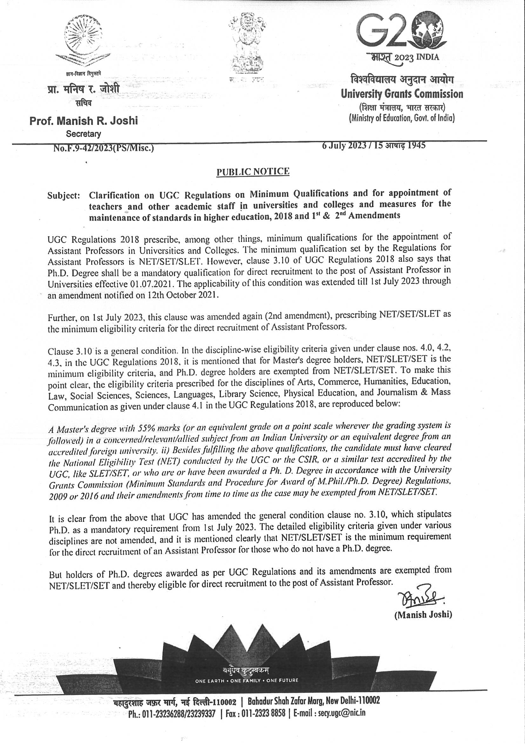

jkpo;ehLclw;fy;tpapay; kw;Wk; tpisahl;Lg; gy;fiyf;fofk;
TAMIL NADU PHYSICAL EDUCATION AND SPORTS UNIVERSITY
(Estd. by the Govt. of Tamil Nadu Under Act No.9 of 2005. A State Govt. University)
Accredited with "B" Grade by NAAC

APPLICATION FOR THE POST OF GUEST LECTURER

Notification No.1682/10-1/TNPESU/Estb.,/R2/GL-T/Phase-II/2023-24
(READ THE INSTRUCTIONS TO THE CANDIDATES CAREFULLY BEFORE FILLING THE APPLICATION)

PART – I

Post Applied for :
University Department
Name of the Post | GUEST LECTURER (Temporary)

Application fee (Non-refundable) : Rs. 500 (Rs. 250 for SC / SCA / ST / DW / PwD)
Demand Draft No. | Date | Amount (Rs.) | Bank Name | Branch & Place

1. PERSONAL DETAILS:
- Name of the Applicant
(In BLOCK LETTERS)
- Date of Birth (DD/MM/YYYY) and Age | Date | Month | Year |  | Age as on date
- Place of Birth | City / State |  |  | Village
- Gender | Male |  | Female |  |  | Transgender
- Marital Status
(Married / Unmarried)
- Nationality and Religion
- Community:
(GT / BC / BCM / MBC / DNC / SC / SC(A) / ST)
- Particulars of Physically Differently Abled, (if applicable)
- Father’s Name
- Mother’s Name
- Mother Tongue
2. CONTACT DETAILS :
Permanent Address | Mailing Address
PIN code : | PIN code :
Email ID :
Mobile Number : | Landline :

3. (a). EDUCATIONAL QUALIFICATION: (From 10th to M.Phil.)

Pattern Of Study : 10 +2 + 3 + 2 / 10 + 2 + 4 + 2 / 11+ 1 + 3 + 2 / 10 + 2 + 3 + 2 + 2
Name of the Examination / Degree | Name of the College / University / Institution / School |  |  | Discipline / Subject | Year of Passing | Marks (%) |  | Division / Class/ CGPA / Rank
(b). UGC-NET/ TN-SLET /  TN-SET Examination |  |  | Year of Passing |  | Reg. No |  | Subject
(c). Research Particulars:

Ph.d., Mode  (Full Time / Part Time) |  | Date of Viva-Voce |  |  | If not awarded, Date of Thesis Submission

Title of Thesis / Dissertation |  |  |  | Subject |  |  | Name of the University
M.Phil.
Ph.D.
Any other higher degree like D.Sc., D.Litt., etc.,
(d). POST DOCTORAL RESEARCH :

S.  No. | University/ Institution |  | Country |  | Duration |  |  | Total Years
 |  |  |  |  | From  (DD/MM/YYYY) | To  (DD/MM/YYYY)

(e). NIS Diploma
Subject | Grade | Year of Passed | Name of the center

- PRESENT POSITION :

Designation | University/ Institution | Date of Appointment | Basic Pay | Pay Level | Gross Pay | Next Increment Date

5. (a) TEACHING EXPERIENCE : (Including current position)

S.  No. | Position Held | Name of the Institution / University | Temporary / Permanent | Period |  |  |  | Total years of service
 |  |  |  | From  (DD/MM/YYYY) |  | To  (DD/MM/YYYY)
(b) RESEARCH GUIDANCE |  |  |  |  | Ph.D. |  | M.Phil.
Number of candidates awarded Ph.D./M.Phil
Number of candidates submitted Ph.D./M.Phil
Number of candidates pursuing Ph.D./M.Phil

6. NUMBER OF PUBLICATIONS
Refereed Journals only, but not in the UGC list | Published |  | Accepted
UGC listed Journals | Published |  | Accepted
Chapters in Books |  | Books (only with ISBN or Similar Identification mark)
Conference proceedings full paper only

7. Name and address of two persons (not related by blood or marriage) from whom confidential reference could be made. They should be in a position to evaluate your candidature for the suitability of the position you are seeking now:
Name:  Designation:  Address:  Phone:  Email: | Name:  Designation:  Address:  Phone:  Email:

8. Name and address of two persons (not related by blood or marriage) from whom you have obtained the enclosed testimonials.
1. | 2.

9. Any Vigilance / Disciplinary case is pending against you? (Yes / No )
If Yes, furnish the details:

10. Any Legal case (including FIR) is pending against you in any of the court(s) / Police station? (Yes / No)

If Yes, furnish the details:

11. Have you ever been dismissed / suspended from service? (Yes / No)

If Yes, furnish the details:

12. Any achievement in Sports and Games

13. Any other information you would like to present for consideration :

14. Declaration :

I hereby declare that all the information provided in this application including the annexure and enclosures are true, complete and correct to the best of my knowledge and belief. I also certify that I have not suppressed / hidden any of the details on the date of submission and in the event of any of the information being found false or incorrect at any stage, my candidature or appointment can be cancelled.

Place :
Date : Signature of the Applicant

PART – II
Details of Academic Record
- Educational Criteria:
 | Under-Graduation | Post-Graduation | M.Phil
Percentage of Marks

- Qualified: Ph.D. /National /State level tests:
Tests/  Fellowship: | Ph.D. | NET with JRF | NET | SLET/ SET  (Within Tamil Nadu)
Yes /No
(With Year)

- Details of Post-doctoral and equivalent experience:
(Provide details of Institute/University where post doctoral position was held, Date of joining and Date of Relieving, Name and affiliation of the research supervisor; enclose self-attested relevant certificates)
- Details of teaching experience:
(Provide details of Institute/University where teaching was carried out, Date of joining and Date of Relieving, Program handled and level of the Program (UG/PG, etc.,); enclose self-attested relevant certificates)

Academic Record to be filled by the Candidate
Academic Record |  | Score |  |  |  |  | Marks Claimed  by candidate | For office use only
1 | Graduation | 80%  Above  = 15 | 60% to less than 80%  = 13 | 55% to less  than 60%  = 10 |  | 45% to less  than 55%  = 05
2 | Post- Graduation | 80% &  Above  = 25 | 60% to less than 80% = 23 | 55% (50% in case of SC/ST/OBC (non- creamy layer)/PWD) to less than 60% = 20
3 | M. Phil. | 60% &  Above = 07 | 55% to less than 60% = 05
4 | Ph.D. |  |  |  | 30
5 | NET with JRF |  |  |  | 7
 | NET |  |  |  | 5
 | SLET/SET (only Tamil Nadu) |  |  |  | 3
6 | Research Publications (2 marks for each research publications published in Peer-Reviewed or UGC-  listed Journals) |  |  |  | 10
7 | Teaching / Post- Doctoral Experience  (2 marks for one year each) |  |  |  | 10
Note:
- If the period of teaching/Post-doctoral experience is less than one year then the marks shall be reduced proportionately
- (i) M. Phil +Ph .D Maximum - 30Marks
  - JRF/NET/SET(TN)/SLET(TN) Maximum - 07Marks
  - In awards category Maximum - 03 Marks.
- Academic Score - 80
Research Publications- 10
Teaching Experience- 10
Total 100
- SLET(TN)/SET (TN) Score shall be valid for appointment in respective
State SLET/SET Universities/ Colleges/ Institutions

As per the UGC Notification dated 18th July 2018

PART – III
Details of Academic / Research Score
- Research Papers in Peer-Reviewed or UGC listed Journals:

S.No | Title of the paper, with Journal’s name, Year of Publication, Vol. No., Page Nos., etc. | ISSN No. | Impact Factor, if any* | Author-ship** | Marks Claimed  by candidate | For office use only
* Impact Factor as per JCR-Thomson Reuter as on year 2019
** For Authorship: Kindly indicate whether you are (i) Single Author (ii) First and Principal/Corresponding author/Supervisor/Mentor or (iii) Other Author/Co-author.
- Publications (other than Research papers):
(a) Books authored
S.No | Publication Type* | Title of the Book Chapter/ Book with details of publication. | ISBN/  ISSN No. | Level  International/  National / Chapter in Edited Book / Editor of Book by International Publisher / Editor of Book by National Publisher | Author-ship** | Marks Claimed  by candidate | For office use only
(b) Translation works in Indian and Foreign languages by qualified faculties
S.No | Publication Type* | Title of the Book Chapter / Book with details of Publication | ISBN/  ISSN No. | Chapter or Research Paper / Book | Author-ship** | Marks Claimed  by candidate | For office use only

* For Publication Type: Kindly indicate whether the publication is (i) Text/Reference/Subject Books, (ii) Edited/Translated Books,(iii)Chapters in Books/Full Paper in Conference Proceedings. For Conference Proceedings only full Papers will be considered, abstracts will not be considered.
** For Authorship: Kindly indicate whether you are (i) Single Author/Editor/Translator, (ii) First and Principal/Corresponding author/supervisor/mentor, (iii) Other Author /Co-author, (iv) First Editor/translator or (v) Co-editor/Co-translator. This should be as per standard definition of the respective terms as applicable to the concerned discipline.

- Creation of ICT mediated Teaching-Learning pedagogy and content development of new and innovative courses and curricula (provide annexure wherever applicable/required) :

- Development of Innovative pedagogy

S.  No | Brief description | Organization for which it was developed | Level:  (PG/UG) | Marks Claimed  by candidate | For office use only

(b) Design of new curricula and courses
S.  No | Brief description | Organization for which it was developed | Level:  (PG/UG) | Marks Claimed  by candidate | For office use only

(c) MOOCs
S.  No | Brief description | Organization for which it was developed | Level:  (PG/UG) | Marks Claimed  by candidate | For office use only
(i) | Development of complete MOOCs in 4 quadrants (4 credit course) (In case of MOOCs of lesser credits, 5 marks/credit)
(ii) | MOOCs (developed in 4 quadrant) per module/lecture
(iii) | Content writer/subject matter expert for each module of MOOCs (at least one quadrant)
(iv) | Course Coordinator for MOOCs (4 credit course) (In case of MOOCs of lesser credits 2 marks/credit)

(d) E-Content
S.No | Brief description | Organization for which it was developed | Level:  (PG/UG) | Marks Claimed  by candidate | For office use only
(i) | Development of e-Content in 4 quadrants for a complete course/e-book
(ii) | e-Content (developed in 4 quadrants) per module
(iii) | Contribution to development of e-content module in complete course/paper/e-book (at least one quadrant)
(iv) | Editor of e-content for complete course/paper/e-book

- Research Guidance/Research Projects

(a) Research Guidance
(i) Ph.D.
S.No | Name of the Scholar | Thesis Title | Thesis Awarded / Submitted | Marks Claimed  by candidate | For office use only

(ii) M.Phil.,
S.No | Name of the Scholar | Thesis Title | Thesis Awarded | Marks Claimed  by candidate | For office use only

(iii) P.G., Level
S.No | Name of the Scholar | Thesis Title | Thesis Awarded | Marks Claimed  by candidate | For office use only

(b) Research Projects Completed
S.No | Title of Research Project | Funding Agency | Period | PI/Co-PI/ Joint PI | Amount  (In Lakh) | Marks Claimed  by candidate | For office use only

(c) Research Projects Ongoing
S.No | Title of Research Project | Funding Agency | Period | PI/Co-PI/ Joint PI | Amount  (In Lakh) | Marks Claimed  by candidate | For office use only

(d) Consultancy
S.No | Title of Consultancy Project | Funding Agency | Period | Amount  (In Lakh) | Marks Claimed  by candidate | For office use only

- Patents/Policy Document
(a) Patents
S.  No | Brief Description | Patent No. | Date of Award | Level:  International/ National | Marks Claimed  by candidate | For office use only

(b) Policy Document submitted to an International body/organization like UNO/ UNESCO/ World Bank/ International Monetary Fund etc. or Central Government or State Government
S.  No | Title of Policy Document | Name of Body/ Organization | Date of Submission | Level:  International/  National/State | Marks Claimed  by candidate | For office use only

(c) Awards / Fellowships:
S.  No | Name of Awards / Fellowships | Awarding Agency | Period |  | Level: International/  National | Marks Claimed  by candidate | For office use only
 |  |  | From | To

6. (a) Invited Lecture / Resource Person
S.No | Title of the Invited Lecture/Paper presented | Title of Conference/ Seminar etc. | Organised  by | Date of  Presentation | Level | Marks Claimed  by candidate | For office use only

(b) Paper Presentation in Seminar / Conference
S.No | Title of the Paper Presentation | Organised by | Date of Presentation | Level | Marks Claimed  by candidate | For office use only

(c) Full Paper Published in Conference / Seminar Proceedings (Should not be
claim marks if it is claimed in 6 (b))
S.No | Title of the Paper Published | Organised by | Date | Level | Marks Claimed  by candidate | For office use only

NOTE: Level shall be, International (Abroad)/ International (within India)/ National/State/ University

7. Future Plans (In approximately 150 words):

OTHER RELEVANT INFORMATION
(Attach self-certified evidence, wherever possible)

- Academic awards and distinctions:
- Membership/Fellowship of Learned bodies/Societies:
- Literary, cultural or other activities(e.g. Attainment in sports etc.) in which the applicant is interested and distinctions obtained:
- Please give details of any other credential, significant contributions, awards received, responsibilities, etc. not mentioned earlier:

I certify that the information provided in the duly filled proforma is correct as per records enclosed.

Date :
Place :
Signature of the Applicant

List of Documents to be Enclosed: Check List
(Must be enclosed along with the Application)

Document | Enclosed (Yes/No)
- Original Demand Draft
- Application Part I & Part II
- Proof of age
- Community Certificate.
- Relevant certificates for educational qualification.
- Mark statements of UG, PG, and M.Phil, (if applicable) degrees.
- Certificate for NET with JRF/NET/SET/SLET/Ph.D.
- Teaching experience certificate from appropriate authority
- Research Guidance: Ph.D. – Proof for number of candidates awarded with the degree/thesis submitted/pursuing.
- Proof for Post Doctoral research
- Copies of the publications in refereed journals with front page
- Cover page of the books published
- First page of the chapters published in edited books.
- Copy of awards/fellowships letters (awards/fellowships given by International Organizations/Government of India/ Government of India recognized National Level Bodies/ State Government), if any.
- Proof for the patents approved /granted/published, if any.
- Copy of award letters of projects.
- Proof of Refresher Courses / Orientation Programme / Faculty Development Programmes / MOOCs attended.
- Employment certificate for each position held and the last pay drawn certificate, if applicable.
- Testimonials.
- Any other relevant documents in support of your application or claim for research score as per UGC Norms.

Date :
Place : Signature of the Applicant

APPENDIX - I
Methodology for University and College Teachers for calculating Academic/Research Score
(Assessment must be based on evidence produced by the teacher such as: copy of publications, project sanction letter, utilization and completion certificates issued by the University and acknowledgements for patent filing and approval letters, students’ Ph.D. award letter, etc,.)

S.  No. |  |  | Academic/Research Activity | Faculty of Languages / Humanities / Arts / Social Sciences / Library /Education  /Physical Education / Commerce / Management & other related disciplines
1. |  |  | Research Papers in Peer-Reviewed or UGC listed  Journals | 10 per paper
2. |  |  | Publications (other than Research papers)
 |  |  | (a) Books authored which are published by ;
 |  |  | International publishers | 12
 |  |  | National Publishers | 10
 |  |  | Chapter in Edited Book | 05
 |  |  | Editor of Book by International Publisher | 10
 |  |  | Editor of Book by National Publisher | 08
(b) Translation works in Indian and Foreign
Languages by qualified faculties
 |  |  | Chapter or Research paper | 03
 |  |  | Book | 08
3. |  |  | Creation of ICT mediated Teaching Learning pedagogy and content and development of new and innovative courses and curricula
 |  |  | (a) Development of Innovative pedagogy | 05
 |  |  | (b) Design of new curricula and courses | 02 per curricula/course
 |  |  | (c) MOOCs
 |  |  | Development of complete MOOCs in 4 quadrants (4 credit course)(In case of MOOCs of lesser credits 05 marks/credit) | 20
 |  |  | MOOCs (developed in 4 quadrant) per module/lecture | 05
 |  |  | Content writer/subject matter expert for each module of  MOOCs (at least one quadrant) | 02
 |  |  | Course Coordinator for MOOCs (4 credit course) (In case of MOOCs of lesser credits 02 marks / credit) | 08
 |  |  | (d) E-Content
 |  |  | Development of e-content in 4 quadrants for a complete course / e-book | 12
 |  |  | e-Content (developed in 4 quadrants) per module | 05
 |  |  | Contribution to development of e-content module in complete course/paper/e-book (at least one quadrant) | 02
 |  |  | Editor of e-content for complete course/ paper /e-book | 10
4 |  |  | (a) Research guidance
 |  | Ph.D. |  | 10 per degree awarded 05 per thesis submitted
 |  | M.Phil./P.G dissertation |  | 02 per degree awarded
 | . | (b) Research Projects Completed
 |  | More than 10 lakhs |  | 10
 |  | Less than 10 lakhs |  | 05
 |  | (c) Research Projects Ongoing :
 |  | More than 10 lakhs |  | 05
 |  | Less than 10 lakhs |  | 02
 |  | (d) Consultancy |  | 03
 | 5 | (a) Patents
 |  | International |  | 10
 |  | National |  | 07
 |  | (b) Policy Document submitted to International body / organization like UNO/UNESCO/World Bank/International Monetary Fund etc. or Central Government or State Government)
 |  | International |  | 10
 |  | National |  | 07
 |  | State |  | 04
 |  | (c) Awards/Fellowship
 |  | International |  | 07
 |  | National |  | 05
 | 6. | *Invited lectures / Resource Person/ paper presentation in Seminars/ Conferences/full paper in Conference Proceedings (Paper presented in Seminars/Conferences and also published as full paper in Conference Proceedings will be counted only once)
 |  | International (Abroad) |  | 07
 |  | International (within country) |  | 05
 |  | National |  | 03
 |  | State/University |  | 02

The Research score for research papers would be augmented as follows:
Peer-Reviewed or UGC-listed Journals (Impact factor to be determined as per Thomson Reuters list) :
- Paper in refereed journals without impact factor - 5 Points
- Paper with impact factor less than 1 - 10 Points
- Paper with impact factor between 1 and 2 - 15 Points
- Paper with impact factor between 2 and 5 - 20 Points
- Paper with impact factor between 5 and 10 - 25 Points
- Paper with impact factor > 10 - 30 Points
Two authors: 70% of total value of publication for each author.More than two authors: 70% of total value of publication for the First/Principal/Corresponding author and 30% of total value of publication for each of the joint authors.
Joint Projects: Principal Investigator and Co-investigator would get 50% each.

Note:

Paper presented if part of edited book or proceeding then it can be claimed only once.
For joint supervision of research students, the formula shall be 70% of the total score for Supervisor and Co- supervisor. Supervisor and Co-supervisor, both shall get 7 marks each.
*For the purpose of calculating research score of the teacher, the combined research score from the categories of 5(b). Policy Document and 6. Invited lectures/Resource Person/Paper presentation shall have an upper capping of thirty percent of the total research score of the teacher concerned.
The research score shall be from the minimum of three categories out of six categories.

As per the UGC Notification dated 18th July 2018

